Untitled

data(pima, package="faraway")  
newpima<-subset(pima,pima$age>0 & pima$glucose>0)  
hist(newpima$glucose,xlab='Glucose',main='Histogram of Glucose')

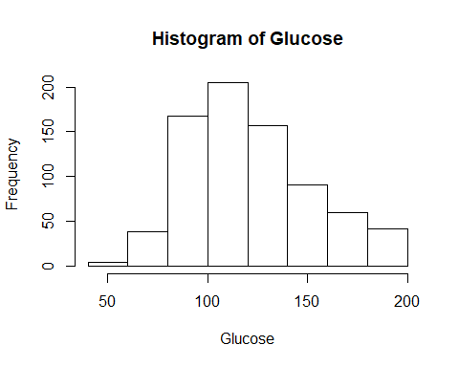

hist(newpima$age,xlab='Age',main='Histogram of Age')

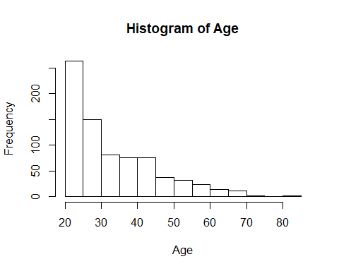

mean(newpima$age)

## [1] 33.2713

mean(newpima$glucose)

## [1] 121.6868

sd(newpima$age)

## [1] 11.77216

sd(newpima$glucose)

## [1] 30.53564

fit1=lm(glucose~age, data=newpima)  
summary(fit1)

##   
## Call:  
## lm(formula = glucose ~ age, data = newpima)  
##   
## Residuals:  
## Min 1Q Median 3Q Max   
## -88.058 -21.310 -3.727 17.615 85.123   
##   
## Coefficients:  
## Estimate Std. Error t value Pr(>|t|)   
## (Intercept) 98.63245 3.19767 30.845 < 2e-16 ***  
## age 0.69292 0.09061 7.647 6.21e-14 ***  
## ---  
## Signif. codes: 0 '***' 0.001 '**' 0.01 '*' 0.05 '.' 0.1 ' ' 1  
##   
## Residual standard error: 29.45 on 761 degrees of freedom  
## Multiple R-squared: 0.07136, Adjusted R-squared: 0.07014   
## F-statistic: 58.48 on 1 and 761 DF, p-value: 6.208e-14

plot(newpima$age,newpima$glucose,xlab='Age',ylab='Glucose', main='Scatterplot of Age and Glucose')  
abline(fit1)

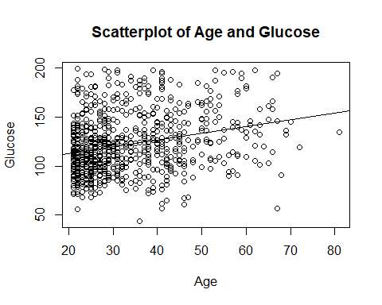

data(GaltonFamilies,package="HistData")  
menheight<-subset(GaltonFamilies,GaltonFamilies$gender=="male")  
fit2=lm(childHeight~father, data=menheight)  
hist(menheight$childHeight, xlab = "Child Height", main="Histogram of Child Height")

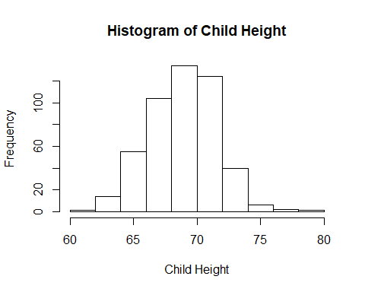

hist(menheight$father, xlab="Father Height", main = "Histogram of Father Height")

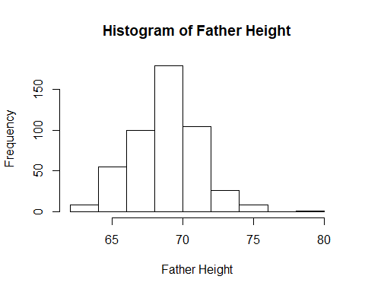

mean(menheight$father)

## [1] 69.13763

mean(menheight$childHeight)

## [1] 69.2341

sd(menheight$childHeight)

## [1] 2.623905

sd(menheight$father)

## [1] 2.305767

summary(fit2)

##   
## Call:  
## lm(formula = childHeight ~ father, data = menheight)  
##   
## Residuals:  
## Min 1Q Median 3Q Max   
## -9.3959 -1.5122 0.0413 1.6217 9.3808   
##   
## Coefficients:  
## Estimate Std. Error t value Pr(>|t|)   
## (Intercept) 38.36258 3.30837 11.596 <2e-16 ***  
## father 0.44652 0.04783 9.337 <2e-16 ***  
## ---  
## Signif. codes: 0 '***' 0.001 '**' 0.01 '*' 0.05 '.' 0.1 ' ' 1  
##   
## Residual standard error: 2.416 on 479 degrees of freedom  
## Multiple R-squared: 0.154, Adjusted R-squared: 0.1522   
## F-statistic: 87.17 on 1 and 479 DF, p-value: < 2.2e-16

plot(menheight$father,menheight$childHeight,xlab="Father Height",ylab="Child Height")  
abline(fit2)

